Emergency Campus Sheltering

Save the Date!

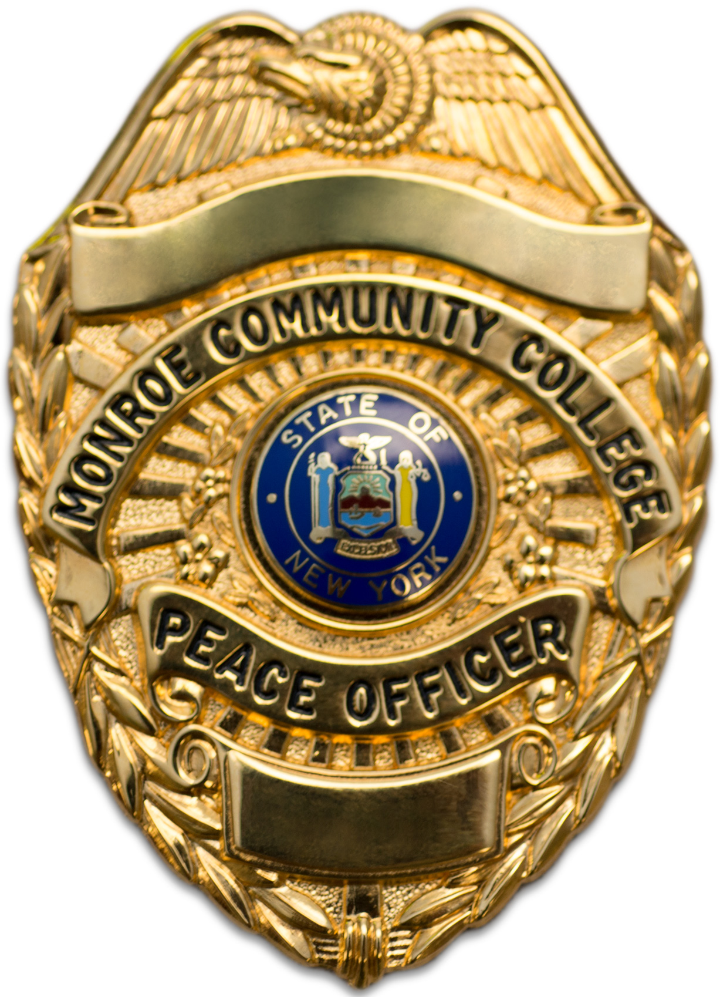

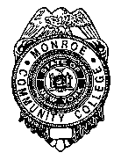
Damon Campus
Campus

Damon

Sponsored by the MCC Department of Public Safety

Monday, September 22, 2014
12:00 pm – 12:50 pm (College Hour)

The Monroe Community College Department of Public Safety will hold a Brown-Bag Session entitled EMERGENCY CAMPUS SHELTERING at the Damon City Campus on Monday, September 22nd from 12-12:50PM in room 4193.
The information shared will address why campus sheltering is needed during an emergency, the definitions/information detailing lockdown procedures and what systems are used to keep you informed during in the case of an emergency.

RSVP by September 19th to Coordinator Richard Schill at
rschill001@monroecc.edu or 292-2926

