INFORMATIONAL MEETING
Monday May 17 at Noon and again at 7PM
ROOM 09-147 (Noon) OR 03-115 (7PM)



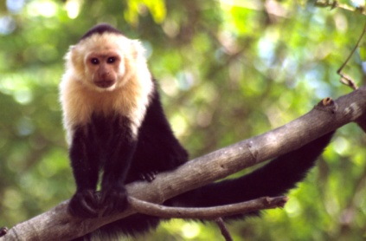
ITINERARY INCLUDES: 12 Days In Costa Rica
World Renown Monteverde Cloud Forest National Park
Tortuguero Marine National Park
Savegre Mountain Resort
Drake Bay and Corcovado National Park
San Jose, Capital of Costa Rica
Included in cost is all International Airfare, In-Country Transportation, Lodging, Meals, Admission Fees

