On Thursday and Friday, February 19 and 20, there will be early morning (5-7am) maintenance done on Banner Production INB and Self-Service. These systems will NOT be down during the maintenance time, however when the changes are complete, you may experience an error in Banner INB that will require you to take action on your PC.

**If you attempt to login to Banner Production INB and receive the following message, please take the action described below.**

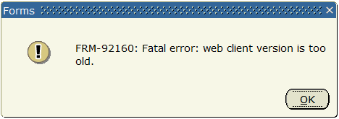

To resolve this problem, you must **clear your Java cache**.

First close any open Banner INB windows (Production or Test)

On your PC, click START, then Control Panel.

From the Control Panel window, click PROGRAMS

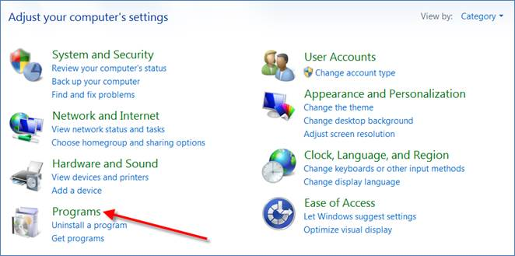

Then click JAVA

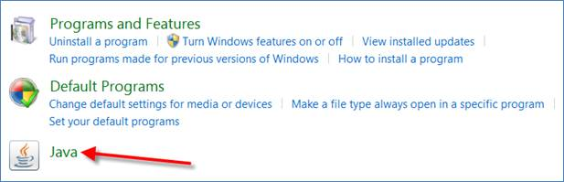

This will display the Java Control Panel.

On the General tab, under Temporary Internet Files, click SETTINGS

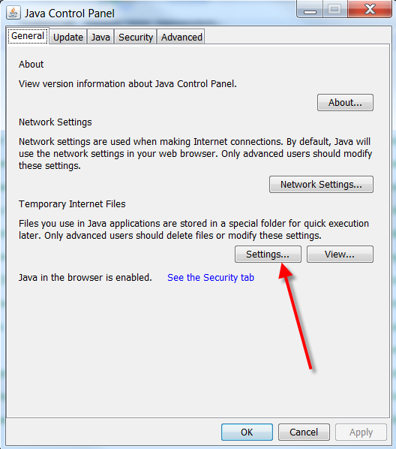

In the Temporary Files Settings window, click DELETE FILES

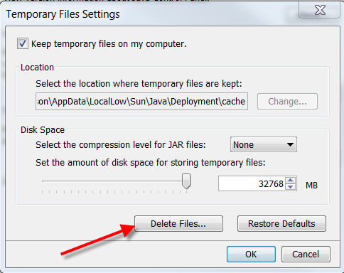

Click OK in the “Delete Files and Applications” window

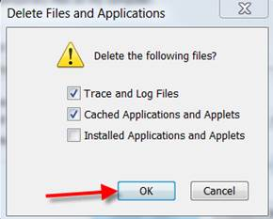

Click OK to exit all the windows.

You can now attempt to login to Banner Production INB again.

If you have any problems with this procedure, please contact the Technology Help Line at x8324.