Why Walk/Run for Water?

In Southern Sudan, women and children walk up to 8 hours a day for water that they must carry home on their backs in jerry cans or in large gourds. Some families have to walk twice daily for water. Once they reach a watering hole, the water is often stagnant and contaminated with disease causing parasites. Life doesn’t have to be this hard for the people of Southern Sudan.

The Solution is Simple
“All this time, people have been dying and we have been sitting right on top of the water?”

Village elder after the first well was drilled
drilled in Southern Sudan
There is plenty of water in aquifers underneath the dusty ground of Sudan. It only needs to be accessed by an organization like Water for Sudan, Inc. who has drilled wells in Southern Sudan since 2005 bringing the life-giving water to over 129,000 villagers. After the first Water for Sudan, Inc. well was drilled, one elder villager said, “All this time, people have been dying and we have been sitting right on top of the water?”

How You Can Help
Walk or Run on October 23rd on the scenic MCC grounds. The first 50 participants who raise $100 will receive a free Water for Sudan t-shirt. Prizes awarded to the top three fundraisers. Pick up your race packet early at the Holocaust, Genocide, and Human Rights office in the R. Thomas Flynn Campus Center, Building 3, Room 138K or the Office of Student Life and Leadership Development in the R. Thomas Flynn Campus Center, Building 3, Room 126. Or check-in on the day of event 9:15-9:50 at the PAC at Monroe Community College. Bring your sponsor sheet and money on the day of the event. Event begins promptly at 10:00.

What One Well Can Do
When a Water for Sudan, Inc. well is drilled, the well becomes the center of life and the world changes:
- women no longer have to travel up to eight hours a day for water leaving time for planting, harvesting, and preparing crops for more nutritious meals.
- More stable structures for schools and clinics can be built with handmade bricks.
- Children can spend their days in school instead of walking for hours to carry water home for their families.
- With water available, health clinics are possible, and simple sicknesses can be tended to.
- Markets will spring up around the well.
- Infant mortality and disease will be dramatically reduced.
- Life becomes much more community centered.

Water for Sudan and The Holocaust, Genocide, and Human Rights Project at Monroe Community College

The Holocaust, Genocide, and Human Rights Project is MCC’s unique organization for telling the stories of the Holocaust and other genocides while transforming individuals to become advocates for human rights. The students of the Project have partnered with Water for Sudan to raise over $36,202 in the last five years.

Water for Sudan, Inc. is a non-profit organization founded by Salva Dut, one of thousands of lost boys who, at age 11, survived Sudan’s civil war by walking across Africa’s harsh wilderness dodging militia to reach safety in refugee camps. Nineteen years after arriving in the United States, he went back to Sudan to search for his father. His father had made it through the war only to be gravely ill from drinking contaminated water. Salva decided then he would find a way to make sure his father never had to drink contaminated water again. He spent the next few years building his not-for-profit Water for Sudan, Inc.

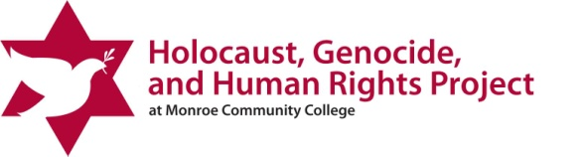
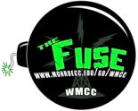
3rd Annual 5k Walk/Run for Water Sponsor Sheet

October 23rd 9:15 check-in 10:00 start: at MCC PAC Center

Individual or Group Name:__________________________________________ Total Raised: $_____________
Address: __________________________________________________________________________________________
Phone: ____________________________________ Email: ________________________________________________

Sponsorship Information
Your donation will help drill water wells in Southern Sudan where women and children walk up to eight hours a day for a meager gallon or two of contaminated water. The ripple effect from one well is profound. When one water well is drilled in Southern Sudan, over 3,000 people have access to clean, safe, life giving water; schools and health clinics can be built; and new markets can change the economic tone of the culture.

Sponsor Name | Address | Email address | Amount  Paid

The first 50 walkers/runners who raise $100 will receive a Water for Sudan T-Shirt.
Prizes awarded to the top three fundraisers.

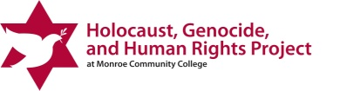
Please turn this form and your collected money in on the day of the walk

