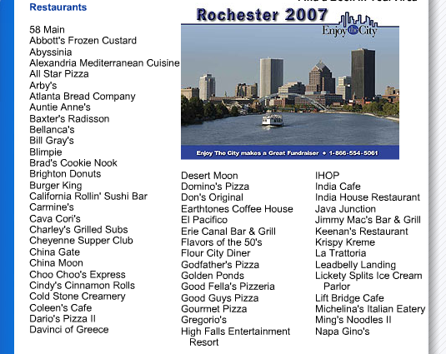
HELP OAU FUNDRAISE

The Outdoor Activities Unlimited Club of MCC is fundraising again. We are selling the 2007 Enjoy the City Coupon Books. What a great holiday gift!

One book for $15
Two books for $25

Please contact Courtney Belluccio at 292-2175 or cbelluccio@monroecc.edu to purchase a book or two.

