CFG gives me an opportunity to interact with colleagues outside of my discipline in a relaxed atmosphere. I gain a greater perspective and feel listened to during each session.
-- Karen Coffey, VaPA

CFGs are
“transformational learning communities fiercely committed to educational equity
and excellence.”
-- School Reform Initiative mission statement

We never get enough time to talk with our colleagues about teaching, and to get the support we need to reach our full potential as teachers. That’s what this group is about.
-- Celia Reaves, Psychology

CFG gives an opportunity to really discuss teaching with colleagues in a deep and meaningful way.
-- Renee Dimino, Transitional Studies

We hope you can join us!

If you have any questions,
please contact:

Gena Merliss
emerliss@monroecc.edu
585-292-2347

Jon Iuzzini
jiuzzini@monroecc.edu
585-292-3319

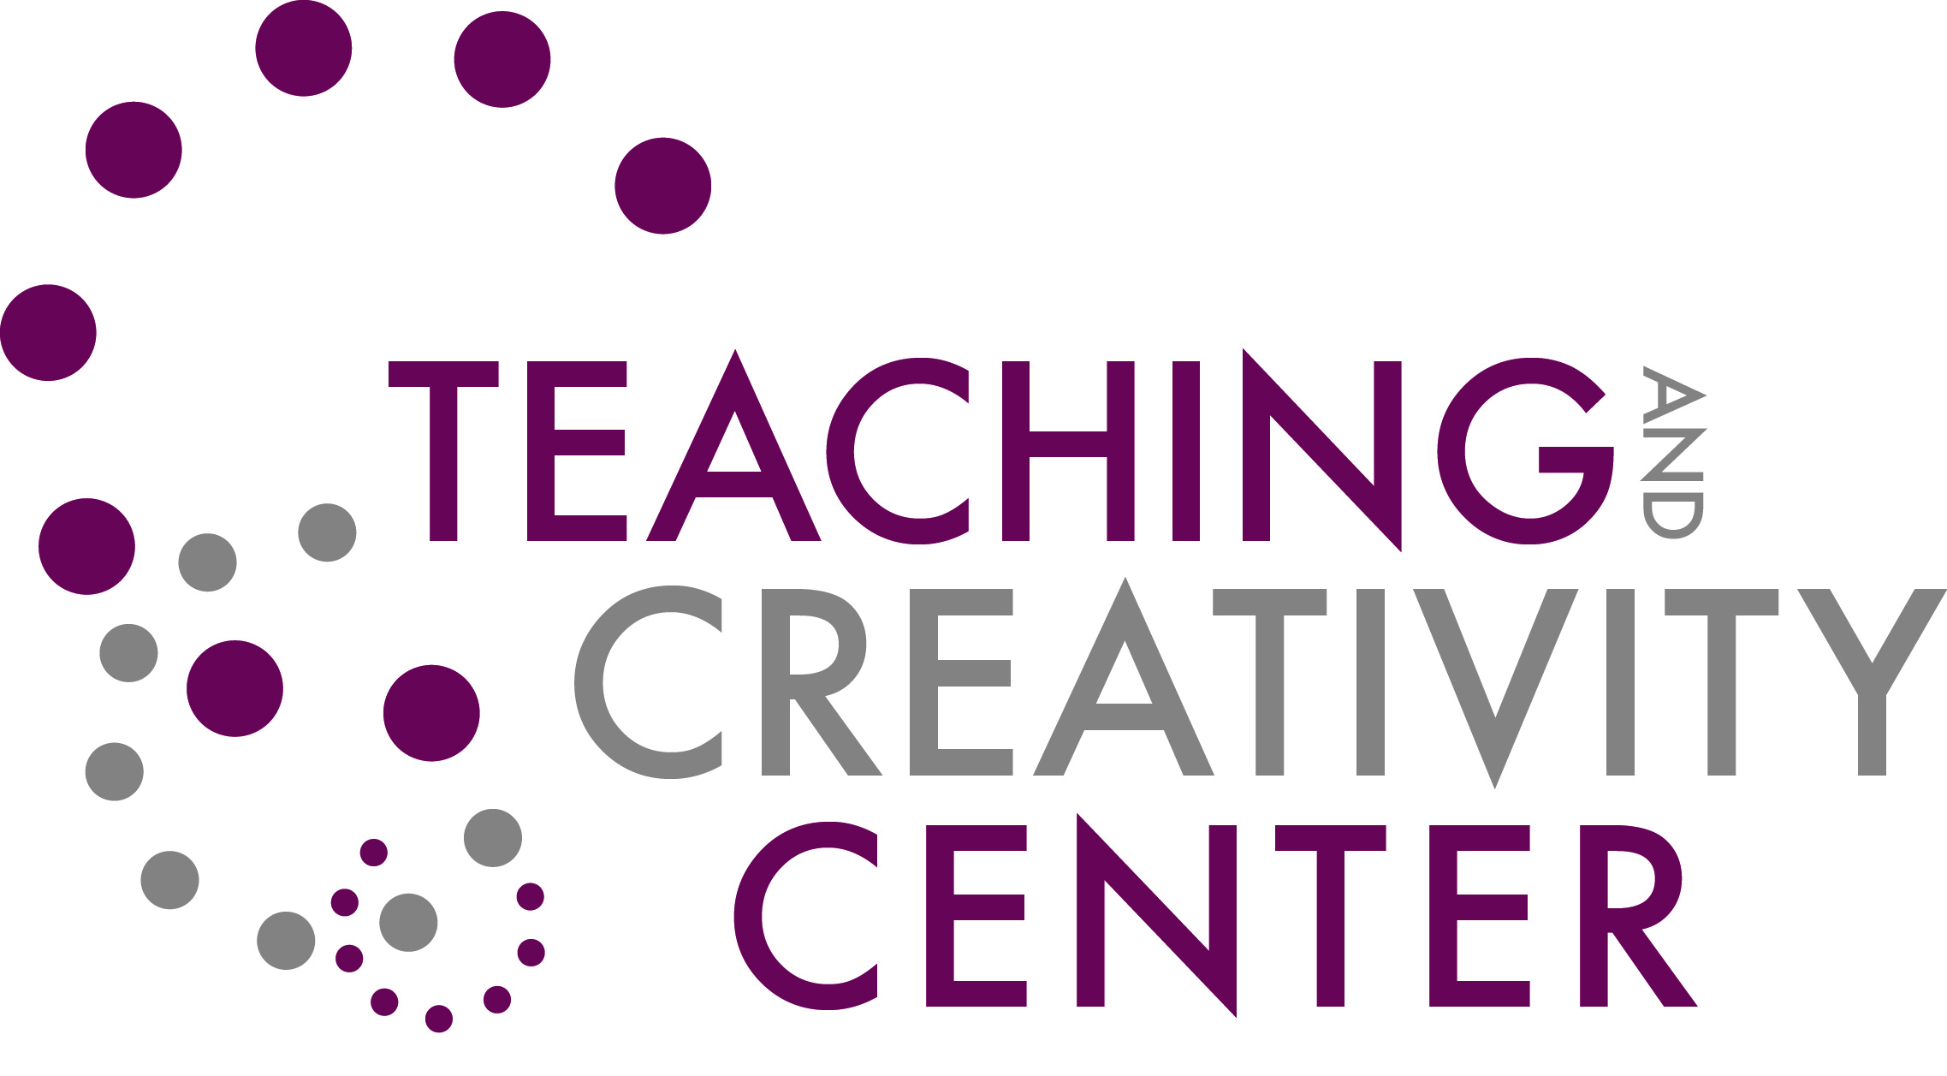

You are invited to join!

Critical Friends Group

A Critical Friends Group helps you reflect critically about your teaching among friends.

Critical Friends Groups
use a nationally recognized
professional development model established to improve student learning and success by
supporting educators reflecting on and improving their practice.

CFGs are led by a trained facilitator and use structured protocols to look at:

- curriculum
- teaching dilemmas
- student work
- peer observations
- pivotal moments

so that participants can provide each other with specific and actionable feedback.

History

In 1994, the Annenberg Institute (at Brown University) charged a group of educators to design professional development that recognized and valued the context of the school, its students, and the strengths of the educators with a focus on improving teaching and increasing student achievement. From there, the CFG was born.
-- www.sri.org

In 2012, MCC’s Teaching & Creativity Center offered its first CFG where we examined each other’s practice in a supportive and non-evaluative environment.

In 2014, several MCC faculty members participated in facilitator training, so that we could expand our CFGs!

We will be offering 3 CFGs for the 2014-15 academic year.

Please contact the facilitators
for the group you
would like to join:

Brighton Campus:
- Gena Merliss, emerliss@monroecc.edu or
- Neeta Primo, nprimo@monroecc.edu

Damon Campus:
- Renee Dimino,
rdimino@monroecc.edu or
- Jim Coffey, jcoffey@monroecc.edu

Adjunct faculty:
- Karen Coffey, kcoffey@monroecc.edu or
- Carlo Atene, catene@monroecc.edu

Sponsored by the Teaching and Creativity Center

