

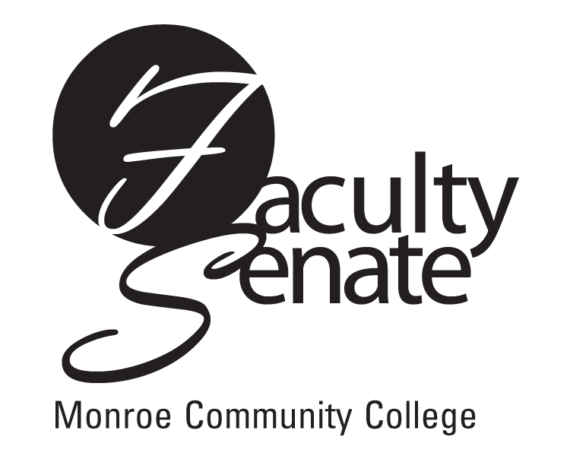
Faculty Senate Meeting Agenda
April 19, 2012 at 3:30 p.m.
Lecture Hall 8-100

1. Matt Fox - Sustainability Program/Degree

2. Announcements

3. Student Announcements

4. Approval of Minutes from March 15th Faculty Senate Meeting

5. Action Items
a. Conduct Regulations
b. Curriculum Proposals:
2012-PR10-Spring - AAS Computer Systems Technology
2012-PR9-Spring – AS Health Studies

6. Standing Committee Reports

7. Focus Item: Senator Discussion re: Retention Strategies

8. Old Business

9. New Business

10. Other

