

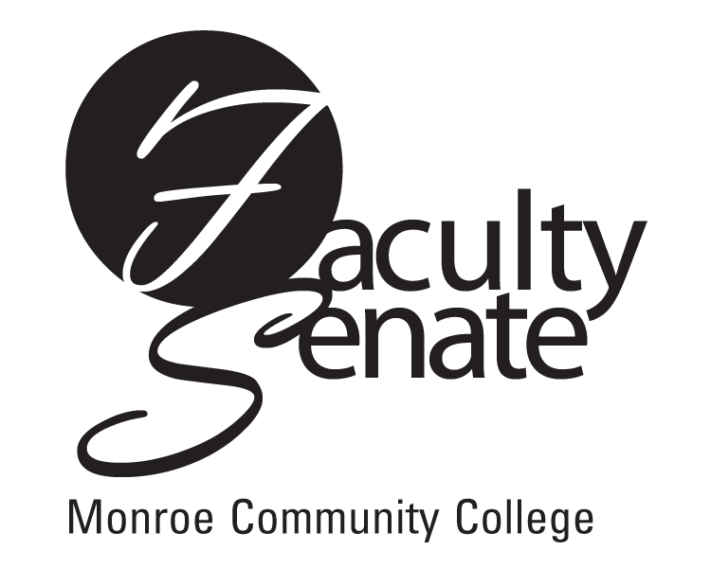
Faculty Senate Meeting Agenda
January 26, 2012 at 3:30 p.m.
Lecture Hall 8-100

1. Guests:
Darrell Jachim-Moore & Cathy Smith
Update on Budget Resource Committee

2. Announcements

3. Student Announcements

4. Approval of Minutes from December Faculty Senate Meeting

5. Action Items:
a. Proposed Endorsement of Resolution from F.C.C.C.

6. Standing Committee Reports

7. Old Business
a. Parking Clarification

8. New Business
Other

