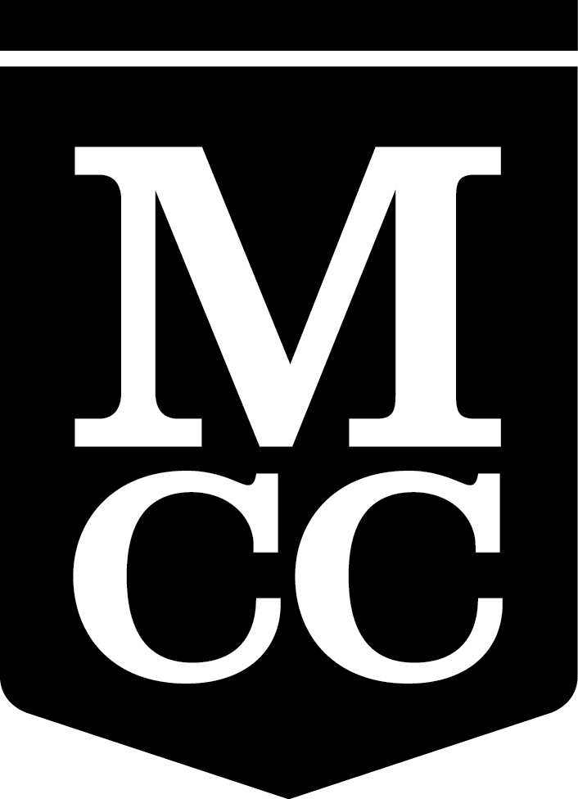
Faculty Senate Meetings
Schedule 2015-2016

All meetings begin at 3:30 p.m.

Faculty Senate
Monroe Community College

Fall 2015
September 17
Lecture Hall 8-200

October 15
Warshof Conference Center, R. Thomas Flynn Conference Center, Monroe B

November 19
Lecture Hall 8-200

December 17
All College Meeting
Warshof Conference Center, R. Thomas Flynn Conference Center, Forum

Spring 2016
All Brighton Campus meetings will be held in the
Warshof Conference Center, R. Thomas Flynn Conference Center, Monroe B

January 28

February 11

March 3

March 17

April 7
Damon City Campus
Community Room 4-193

April 21

May 5

May 19

June 9
All College Meeting

