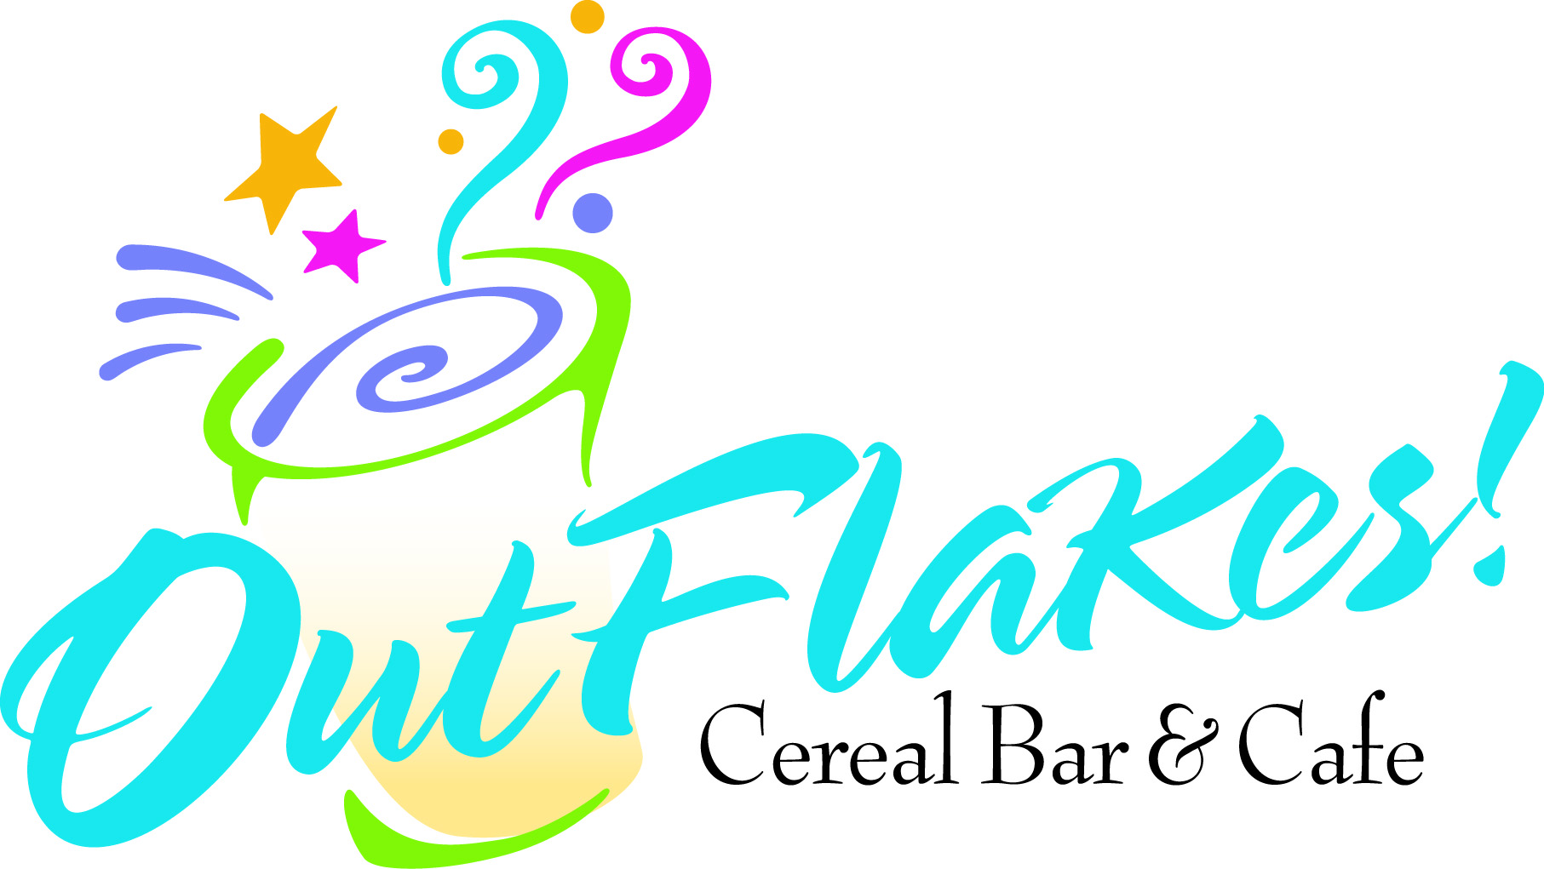
It’s a Wrap $4.95
Served with Tri-Colored Tortilla Chips
OutFlakes Club
Turkey Breast and/or Ham, Bacon, Provolone, Crisp Lettuce, Tomato, Wrapped in a Tortilla
Chicken Caesar
Grilled Chicken Breast, Romaine, Parmesan, Creamy Caesar Dressing, Wrapped in a Tortilla
Buffalo Chicken
Grilled Chicken Breast, Buffalo Sauce, Crumbly Blue Cheese, Crisp Lettuce, Wrapped in a Tortilla
Supreme Roast Beef
Premium Roast Beef, Roasted Red Peppers, Red Onions, Provolone, Wrapped in a Tortilla
Deluxe Turkey
Roasted Turkey Breast, Romaine, Tomato, Red Onion, Cranberries, Wrapped in a Tortilla
Ham & Swiss
Ham, Swiss Cheese, Romaine, Tomato,
Honey Mustard, Wrapped in a Tortilla
Chicken Salad
Freshly Made Chicken Salad (Add Grapes and/or Walnuts), Romaine, Tomato, Wrapped in a Tortilla
Tuna Salad
Freshly Made Tuna Salad (Add Apples and/or Walnuts), Romaine, Tomato, Wrapped in a Tortilla
Caprese Salad NEW
Crisp Lettuce, Tomatoes, Mozzarella Cheese, Blue Cheese, Onions, Drizzled with Balsamic Vinegarette, Wrapped in a Tortilla
Greek Salad NEW
Crisp Lettuce, Tomatoes, Onions, Kalamata Olives, Drizzled with Greek Vinegarette and topped with Feta Cheese, Wrapped in a Tortilla
Tortilla Flavors
Plain, Wheat, Spinach, Sun Dried Tomato, Garlic Pesto
Feel Like a Bagel? Just Ask!!
Add some Zing to your WRAP WITH our Wasabi Mayonnaise
Grape, Apple & Walnut Additions
$.50 per Wrap

Eat Cereal.

All Day.

Everyday.

Located in the R. Thomas Flynn Campus Center next to the MCC Bookstore.

To Order Ahead, Call:

292-8309

We Accept 

Infinite Hot and Cold Cereal Combinations

Starbucks Coffee and Specialty Espresso Drinks

Delicious Freshly Made Wraps

All Natural Fruit Smoothies

Yogurt & Fruit Parfaits

Scrumptious
Cereal Bars

Pastries
Bagels
Scones
Cinnamon Twists Cookies
Espresso Brownies

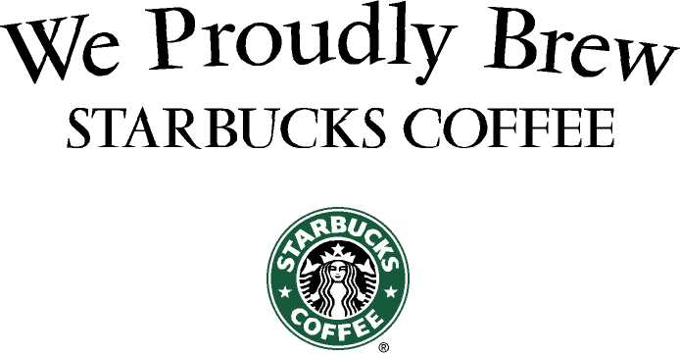
 | Tall |  | Grande | Venti
Coffee |  | $1.45 | $1.65 | 1.75
Tazo Tea |  | $1.15 | $1.65 | $1.65
Tazo Chai Latte |  | $2.70 | $3.10 | $3.35
Cappuccino |  | $2.55 | $3.10 | $3.40
Latte |  | $2.55 | $3.10 | $3.40
Flavored Cappuccino |  | $2.85 | $3.40 | $3.70
Flavored Latte |  | $2.85 | $3.40 | $3.70
Café Mocha |  | $2.75 | $3.30 | $3.55
White Mocha |  | $3.20 | $3.75 | $4.00
Caramel Macchiato |  | $2.80 | $3.40 | $3.65
Americano |  | $1.75 | $2.05 | $2.40
Double Espresso |  | $1.75
Hot Cocoa |  | $2.20 | $2.25 | $2.70
Iced Tea |  | $1.45 | $1.65 | $1.75
Iced Tazo Chai Latte |  | $2.70 | $3.20 | $3.35
Iced Latte |  | $2.55 | $3.10 | $3.50
Iced Flavored Latte |  | $2.85 | $3.40 | $3.80
Iced Café Mocha |  | $2.75 | $3.30 | $3.70
Iced White Mocha |  | $3.20 | $3.75 | $4.15
Iced Carm. Macchiato |  | $2.80 | $3.40 | $3.80
Iced Latte Creamice |  | $3.00 | $3.50 | $4.00
Iced Mocha Creamice |  | $3.25 | $3.75 | $4.25
Iced Caramel Creamice |  | $3.25 | $3.75 | $4.25
Iced Vanilla Creamice |  | $3.25 | $3.75 | $4.25

All Cereal $2.75

Just What the Student Ordered

2 Scoops of Cereal
Add 1 Topping
Pour Milk

Just What the Professor Ordered
Flynn's Smart Flakes
Smart Start, Frosted Flakes & Blueberries
Salvador's Berry Special Heart
Special K w/ Berries, Kashi Heart to Heart & Strawberries
The All Nighter
Lucky Charms, Cocoa Puffs & Malt Balls
Raisin' Your Grades
Raisin Bran, Smart Start & Banana
Life is but a Dream
Life Cereal, Banana, Almonds & Honey

Hot Cereals
Jamison’s Favorite
Oatmeal, Glazed Walnuts, Cranberries,
Brown Sugar & Maple Syrup
Apple Brown Betty
Oatmeal, Apples, Brown Sugar,
Cinnamon & Maple Syrup
S’More Oatmeal
Oatmeal, Mini Marshmallows,
Chocolate Chips & Brown Sugar
Fruit & Cream
Oatmeal, Milk, Strawberries & Blueberries
Sweet Sensation
Oatmeal, Reese’s Pieces & M&Ms
Oatmeal & Yogurt
Oatmeal, Vanilla Yogurt, Apples & Raisins
Tom’s Media Frenzy
Oatmeal, Cheerios, Blueberries & Almonds

Smoothies
Our Way. All Day. Everyday.

16 oz. $3.09 20oz. $3.69

Banana Berry Burst
Low-Fat Natural Yogurt, Orange Juice, Banana & Strawberries
Berry Blitz
Low-Fat Natural Yogurt, Apple Juice, Banana & Blueberries
Cape Codder
Low-Fat Natural Yogurt, Cranberry Juice, Apple Juice& Blueberries
Banfandango
Low-Fat Natural Yogurt, Orange Juice, Banana & Mango
Peanut Butter Bonanza
Low-Fat Natural Yogurt, Skim Milk, Banana & Peanut Butter
Peach Blueberry Blast
Low-Fat Natural Yogurt, Orange Juice, Blueberries & Peaches
Peanut Butter Banana Surge
Soy Milk, Chocolate Protein, Banana & Peanut Butter
Soy Smoothie
Soy Milk, Honey, Banana & Strawberries
Strawbana
Low-Fat Natural Yogurt, Orange & Apple Juice, Banana & Strawberries
Triathlete
Orange Juice, Banana & Strawberries

