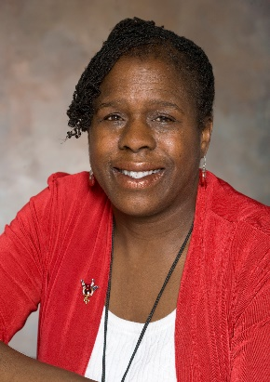

Dr. Clark is a professor at the Rochester Institute of Technology (NTID) in Rochester New York. She is a consultant and a professional audiologist with over 20 years of experience in her field.

