MCC NIGHTS WITH THE

Free!

Sunday, July 28 vs. Antigua @ 4:05 – Kids Day!
Fri., August 2 vs. Dayton @ 7:35 - Fireworks
Fri., Aug. 9 vs. Pittsburgh @ 7:35 - $1 Hot Dogs & Drafts Pre-game

Specially discounted pricing:
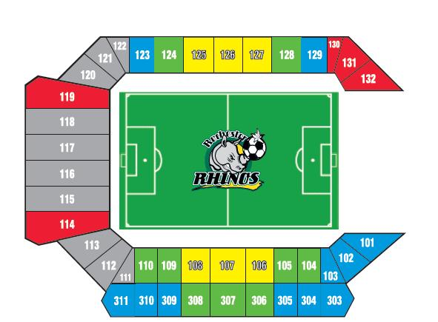
Seating Section | Disc. Price | Window Price
Club | $15.00 | $20.00
Premium | $12.00 | $18.00
Sideline | $10.00 | $13.00
Gen. Admission | $ 7.00 | $10.00
Don’t miss your chance to see the Rochester Rhinos in their final 3 regular season games this summer at Sahlen’s Stadium! MCC faculty, staff & alumni can receive specially discounted ticket prices by contacting Colleen Brown! Below are your options for ordering. All orders for games must be received 24hrs. in advance.
Mailing orders: Rochester Rhinos Phone, fax or e-mail orders:
Attn: Colleen Brown 585-454-3000 ext. 115
460 Oak Street fax: 585-454-7000
Rochester, NY 14608 cbrown@rhinossoccer.com

Rochester Rhinos MCC Order Form

Name: ______________________________________ Phone: _______________________________

Address: ____________________________________ Email: ________________________________

City: State: ______________ Zip:

Date of Game: Seating Section:

Number of Seats: @ $ each Total Due $

Payment Options: Credit/Debit Card: AMX: ___ DISC: ___ MC: ____ VISA: ___ Check #:

CC# ____________________________________ Exp. _________ CCV: ___________
Make checks payable to: Adirondack Sports Club LLC

