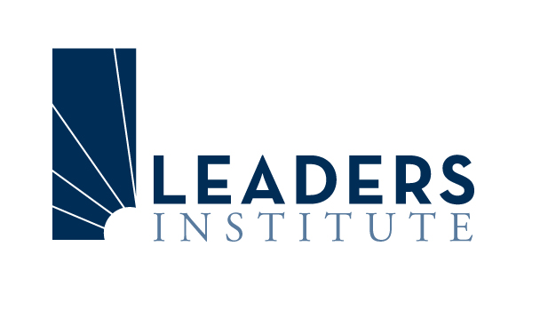

Application

Baltimore, Maryland
June 2010

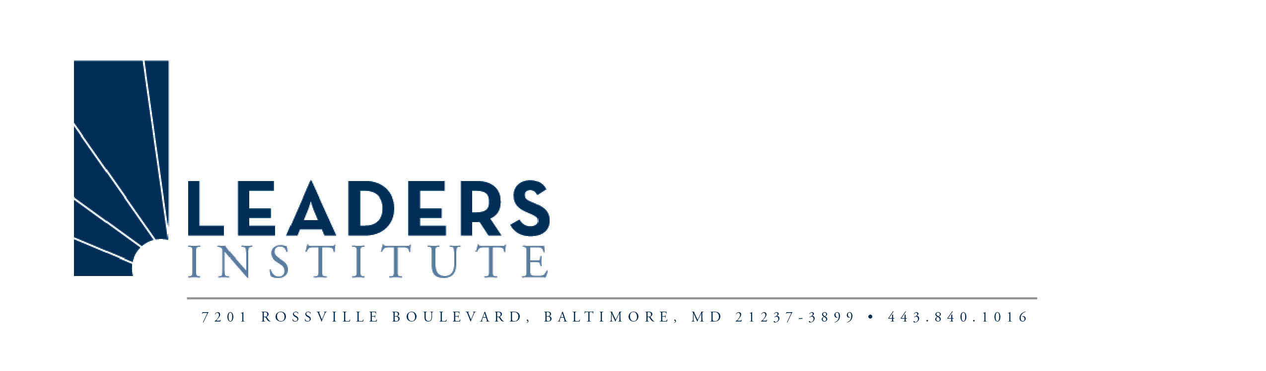
APPLICATION FORM
LEADERS 2010
The Premier Program Developing Women Leaders in Community Colleges

Name:
Last First Middle

Title:

Name and title of immediate supervisor:

Institution: Campus:

Address:
Institution:
Street City State Zip

Home:
Street City State Zip
Telephone:
Work: Home: Cell:
E-mail address: Fax:
Birthday-Month/Day:
Medical/ Dietary Needs:
Name and Title of Mentor:
Project Title:

Location and Date of LEADERS 2010 Institute
Baltimore, Maryland: June 7–11, 2010
LEADERS STATEMENT
(To be completed by applicant. Use additional paper as needed.)
Current Activities:
- Briefly describe the programs, activities, and services for which you are responsible.

- What are the two most important challenges that you face in your current position and why are they a challenge?

- What is your ultimate career goal in higher education?

- From your perspective what steps/positions do you need to progress through to reach your career goal?

- What experiences do you think you need to enhance your qualifications, vita or resume for the next step in your career path?

Purpose Statement:
Explain your purpose for attending LEADERS and identify what you bring to the program.

Applicant
Name:
Signature: Date:

Chief Executive Officer Statement
I agree to this applicant’s participation in the LEADERS Institute.

Name: Title:
(Please Print)

Institution:

Signature: Date:

LEADERS PROJECT
Leaders Institute
Leaders Institute
(To be completed by applicant. Use additional paper as needed.)

As a participant in the Leaders Institute, I will complete the following project during the next twelve months:
Name:

Project Title:

Project Description:

Project Goal(s):

Project Objectives:

Measureable Outcomes:

Approach:
How do you propose to complete your goals and objectives for this project? What specific tasks will be involved? What activities will be conducted?

Collaboration:
Will other areas of the college be involved? If so, how will you involve them? If not, how could you involve them?

Administrative Skills:
What new administrative skills will you gain from this project?

Institutional Benefits:
How will this project benefit your college?

Evaluation upon Completion of the Project:
What specific methods did you use to determine the success of this project? What were the major things learned from your project? What could you have done differently?

MENTOR STATEMENT
(To be completed jointly by mentor and applicant. Use additional paper as needed.)
Mentor: A mentor is defined as an experienced, trusted teacher who helps a less experienced person learn needed skills.
Name of Mentor:
Mentor’s Current Position:
Institution:
Address:
City/State/Zip:
Phone: (wk) Fax:
E-mail:
Years of administrative experience:
In what specific ways do you, as a mentor propose to help the applicant develop administrative and leadership skills; and complete their project?

How will you evaluate these skills?

To be completed by the Applicant:
State your reason(s) for your mentor choice:

Mentor/Applicant Agreement
Confidentiality, integrity, trust, and open and honest communication are essential between mentor and applicant. We have discussed this relationship and believe that we can work well together.
Applicant: Mentor:

Print Name Print Name

Signature Date Signature Date

