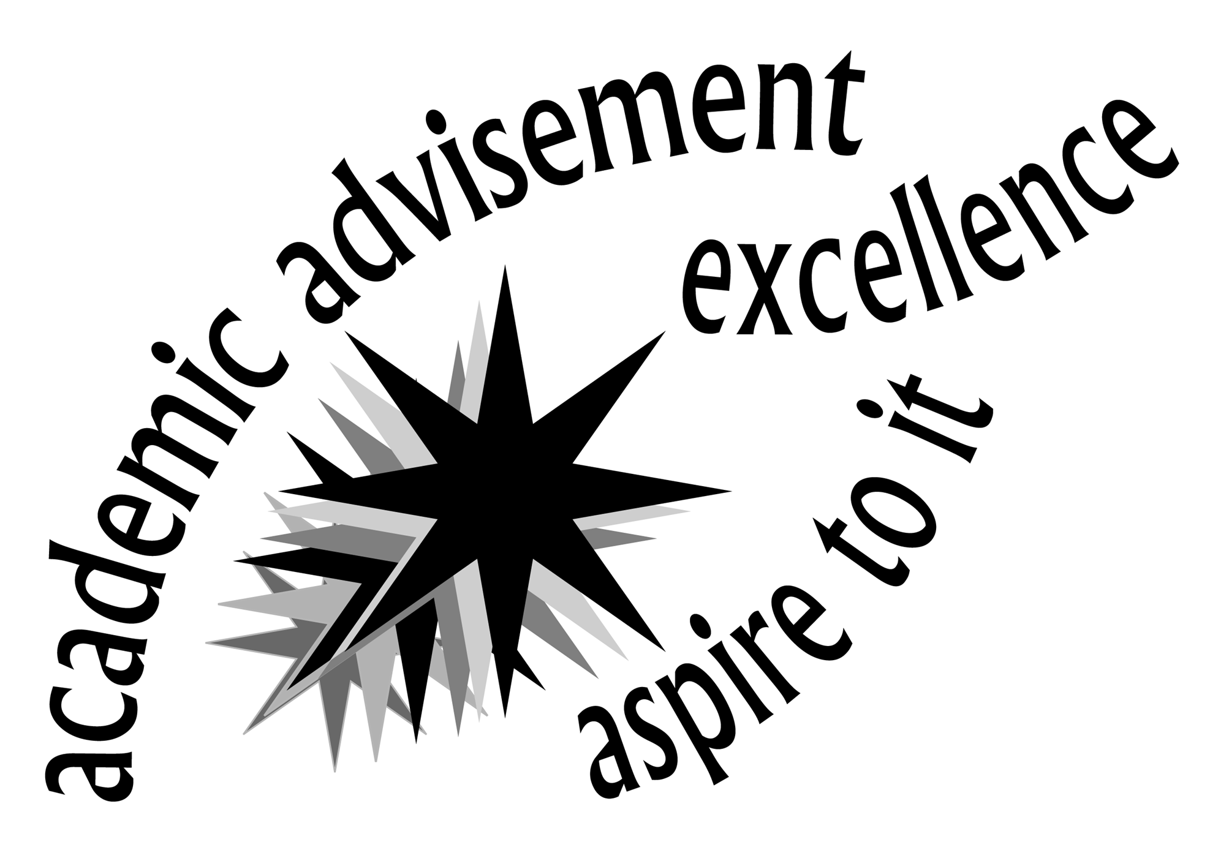

8th Annual Academic Advisement Contest

Topic for faculty response:

Lessons about Advisement: What Would You Share with a New Faculty Advisor?

(Ideas to consider: What have you learned that has made advising “easier”? What are the challenges you face and how do you work to resolve them?)

Guidelines:

- Submit all entries to Michele Vitale, Counseling and Advising Center (1-231), mvitale@monroecc.edu, no later than December 4, 2009. Please include your name, email address and extension.

- Limit your typed response to one page.

- A $25 gift certificate for the MCC Bookstore will be awarded to one faculty member on the basis of freshness and quality of responses. (Thank you MCC Bookstore for your generous donation!)

- The prize-winning entry will also be published in the Tribune.

Call Denise Klein (2295), Jennifer Kinslow (2297) or Kathy O’Shea (3339) with any questions.

