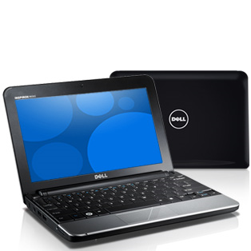
DELL
Inspiron Mini 10
$359.99
Excludes any other discount

Software & Services:
- Genuine Windows® XP Home Edition SP3
- Intel® Atom Processor® N270 (1.6GHz/533Mhz FSB/512K cache)
- Microsoft Works 9 ***DOES NOT INCLUDE MS WORD***
- 1Yr Ltd Warranty and Mail-In Service
- 160GB, 2.5inch, 5400RPM SATA Hard Drive
- 24WHr Lithium-Ion Battery (3-cell)
- Wireless 802.11g (1397) Mini Card

Color:
- Obsidian Black

Accessories:
- McAfee Security Center (30-Day Trial)

Take your computer today – make payments later!
Call extension 2502 to set up your store account today!

