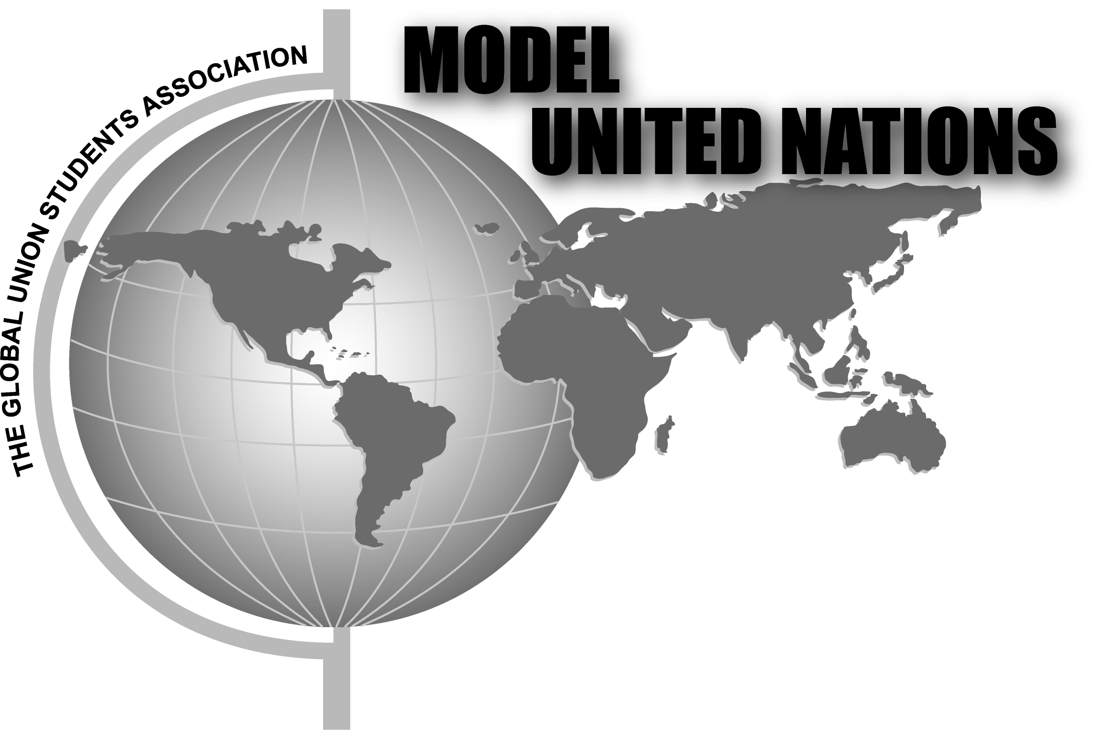

The Global Union International Student Association
Proudly Presents



(Music Host WMCC the Fuse)

- Singing
- Dancing,
- Music
- Instrumental artistic talent
- Sample food from different Cultures
- $100.00 is awarded to the best performer or group act

This is one of the year’s largest and greatest events on campus. It is also the time when everyone comes together to celebrate the Diversity on campus:

Join Us!
When: Wednesday, May 2, 2007
Where: Monroe A&B (in the Warshof Campus Center) & Marketplace
Time: Starts at 12:00 p.m. to 2:00 p.m.

.

