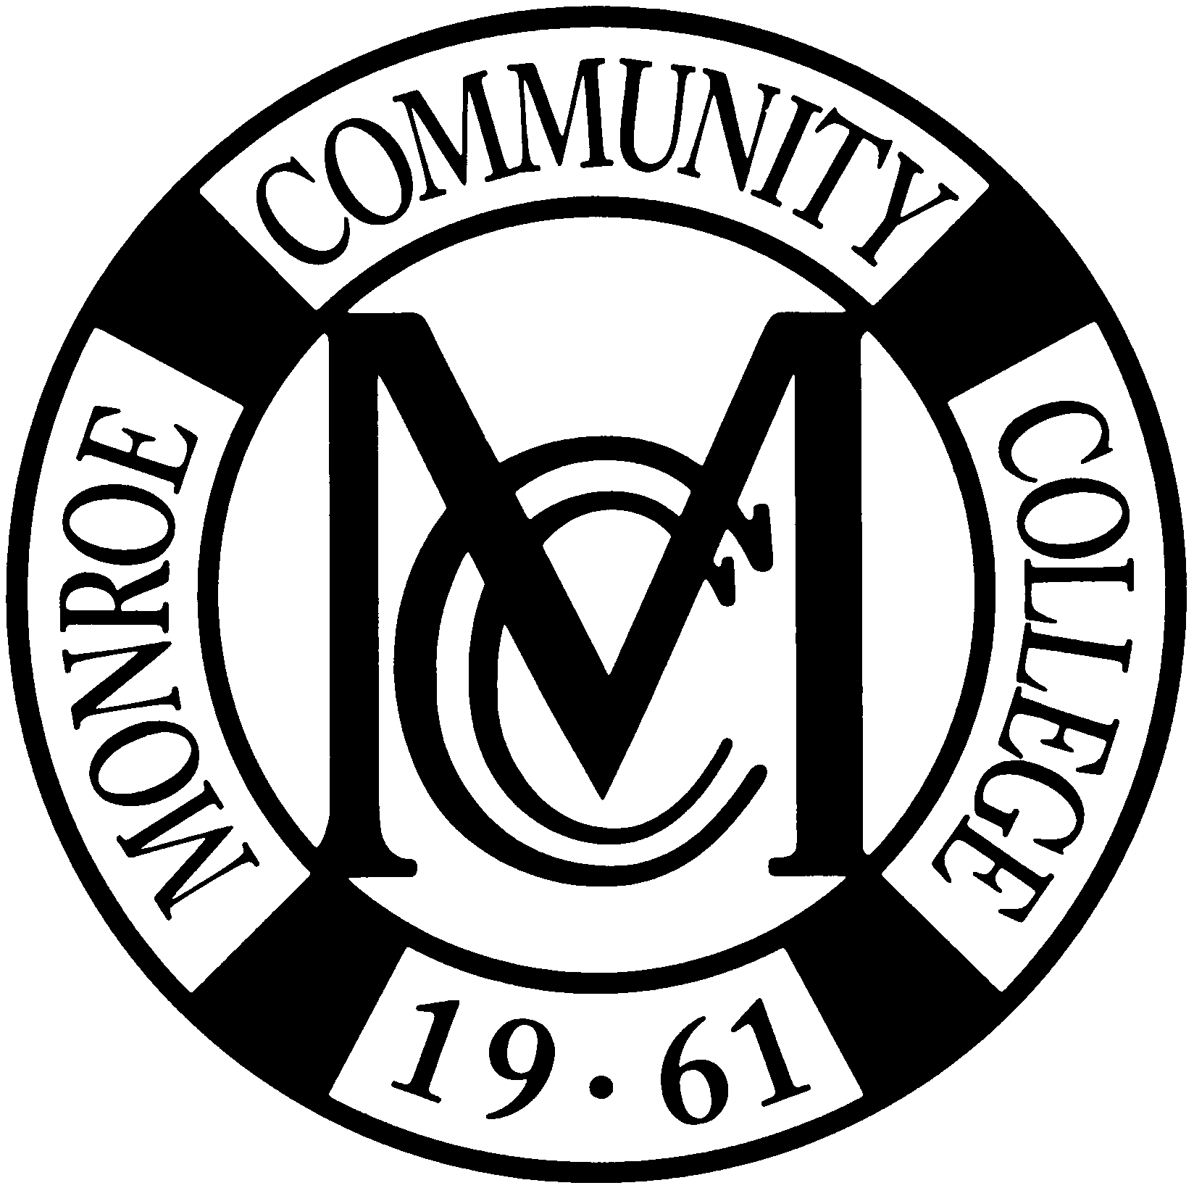

Monroe Community College
2009 Class Gift Dedication

Dear Monroe Community College Faculty and Staff,

The Monroe Community College Foundation is pleased to offer you this special opportunity to congratulate a member of the Class of 2009 and support the college this spring. Just write a tribute to a graduating Monroe Community College student and it will be included in the MCC 2009 Commencement Keepsake. Submit your tribute using this form along with a minimum gift of $10 to secure your spot in the keepsake! Proceeds go towards the MCC Annual Fund and support scholarships and programs for future MCC students. The deadline for submissions is April 27, 2009!

Tribute Sample:
Sarah Johnson, from Professor Wilson, Visual and Performing Arts
“Your enthusiasm and talent know no boundaries. Congratulations on earning your degree. The world is now your stage. Best of luck at the Eastman School of Music!”

Please use the form below to submit your dedication (max: 40 words). Please return your completed form and gift of $10 (minimum) by April 27, 2009. You may submit your dedication at the Campus Center Desk at MCC’s Brighton Campus or at the MCC Foundation at the Damon City Campus (Room 5-032). Please print legibly or your entry may not be used. The Tribute Committee will review all comments and reserves the right to refuse and edit tributes without notice. Late entries will not be accepted.

Name: __________________________________________ (MCC faculty or staff member)
Please make checks payable to the MCC Foundation!
Honoree: ________________________________________ (MCC student)

My dedication (40 words max.):


Forms must be received by April 27, 2009.
Please call the MCC Foundation at (585) 262-1500 with any questions.

Thank you for supporting Monroe Community College.

