MCC’s 4th Annual Geography Quiz

Geography Awareness Week 2009
(Get Lost in Mapping: Find Your Place in the World)

Geographic Techniques Questions:

- _____ is the science of making maps.
- Demography
- Cartography
- Topography
- Geomorphology

- Location determined by relating an unknown location to a known location is called _____; location determined by using a reference system to find an exact point is called: ______.
- site, situation.
- situation, site.
- relative location, absolute location.
- absolute location, relative location.

- Latitude determines _____ location by using lines that run _____ on Earth.
- east or west, north to south
- east or west, east to west
- north or south, north to south
- north or south, east to west

- Rochester, New York (43º 9’ north) falls within this latitude zone.
- Arctic
- Subarctic
- Midlatitudes
- Subtropics

- Longitude determines _____ location by using lines that run _____ on Earth.
- east or west, north to south
- east or west, east to west
- north or south, north to south
- north or south, east to west

- The maximum value for latitude is _____ and the maximum value for longitude is: _____.
- 90º, 90º.
- 90º, 180º.
- 180º, 90º.
- 180º, 180º.

- Map scale is:
- the system used by geographers to transfer locations from a globe to a map.
- the spread of something over a given area.
- the difference in elevation between two points in an area.
- the relationship between distance on a map to distance in reality.

- A map scale of _____ would best serve a tourist visiting Washington D.C. because it is a _____ scale map.
- 1:500,000, small
- 1:500,000, large
- 1:10,000, small
- 1:10,000, large
- You are having some friends over for a party at your new house. The map you want to include with the invitation is too big so when you make copies you reduce it to half of its original size. Which of the following scales would remain correct even though you have changed the size of the map?
- written or word scale
- large or small scale
- graphic or bar scale
- representative fraction or fractional scale

- _____ map projections portray accurate sizes but distort the shapes of landmasses; _____ map projections portray accurate shapes but distort the sizes of landmasses.
- Conformal, equivalent
- Mercator, Goode
- Equivalent, conformal
- Cylindrical, conic

- A geographic tool that calibrates satellite signals to accurately determine location, elevation, and other useful information is called:
- a Global Positioning System (GPS)
- a Geographic Information System (GIS)
- a passive Remote Sensing
- an active Remote Sensing

- Many geographers use satellite imagery to study the spatial relations of physical and cultural environments. This type of technology is called:
- cartography.
- human geography.
- physical geography.
- remote sensing.
- Using the image below, which of these locations had the lowest and highest average annual precipitation in New York state?
- Kingston; Old Forge
- New York City; Jamestown
- Old Forge; Watertown
- Rochester; Old Forge
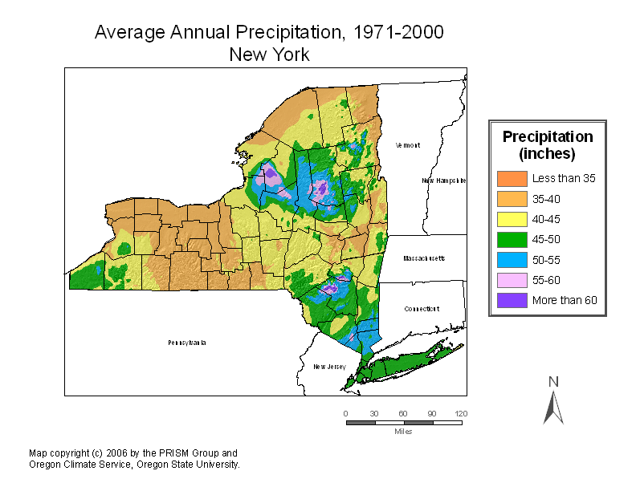
- Generally urban counties are younger than rural ones, but there are exceptions. The youngest county in New York state is home to a world renowned university. According to the map below, which county has the youngest median age in New York in 2000 and what is the median age in Monroe County? Image source: Tim McDonnell, New York Geographic Alliance.
- Monroe; 30-35
- Tompkins; 35-37
- Nassau; 30-35
- Queens; 35-37
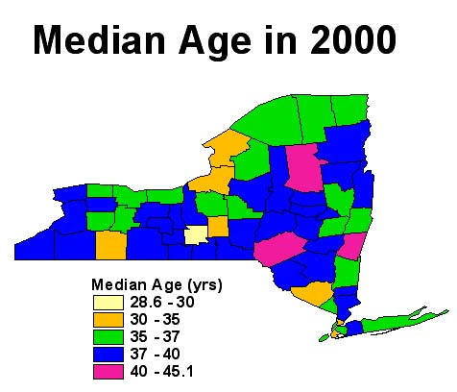

- Geographic Information System (GIS) is defined as:
- A multibillion- dollar industry and business
- An approach to the scientific analysis and use of spatial data
- A special case of an information system designed to analyze the climate to wind energy to medical issues.
- All of the above

16. What is the name of the city located below and what is the predominant feature in the image? Hint: A ferry will take you from here to within blocks of the Freedom Trail.
A. Florida Keys, FL; island
B. Cape Hatteras, NC; barrier island
C. Provincetown, MA; spit
D. Tybee island, Georgia; river delta

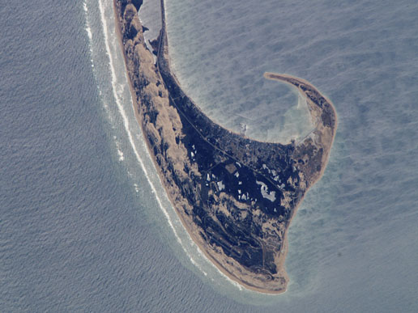

17. Observing the earth from space using satellite images of the earth’s surface is important for understanding the planet. Since 1972, the USGS has operated the Landsat (“Landsatellite”) series of satellites to understand the earth in terms of global climate change, agriculture, forestry, geology, and more.

The Landsat images are color composite images created by assigning colors to bands in the electromagnetic spectrum. Vegetation appears as shades of red. Brighter reds indicate more vigorously growing vegetation. Soils with no vegetation or sparse vegetation range from white, indicating sands, to greens or browns, depending on soil moisture and the content of organic matter. Water bodies appear blue or black. Deep, clear water will be dark blue to black in color, while water that is shallow or laden with sediment will appear lighter in color. Urban areas appear blue-gray in color. Clouds and snow appear bright white. Clouds will have a puffy or popcorn shape with shadows often apparent.

Examine the following images of this body of water in the eastern hemisphere from 1963 (top) to 1987 (bottom). What is the name of the lake and what is happening?
- Caspian Sea; disappearing/evaporating
- Dead Sea; water is being diverted
- Lake Baykal; drought
- Lake Chad; water is being diverted and drought conditions have persisted.

18. The two images below show a before and after scene of an urban area in the mid-Atlantic that
was devastated by a tornado. What part of this image (west or east) seems to have the largest concentration of development? What state did it occur in?
- East; Maryland
- West; Delaware
- East; Texas
- West; Louisiana

19. Perhaps you have wondered where you would end up if you could dig a hole to the other side of earth. An antipode is the point on the Earth's surface which is diametrically opposite to it. Which state in America has an antipode that is not an island or an ocean? What is the antipode of NY state?

- Colorado; Red Sea
- Texas: Pacific Ocean
- Hawaii; Indian Ocean
- Florida; Straits of Magellan
- California; Atlantic Ocean

Topographic maps are characterized by large-scale detail of various features and lines of equal elevation (contour lines). Match the topographic map with the National Park:

- Mammoth Caves - C
- Yosemite - F

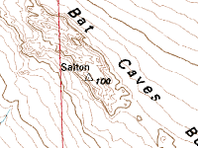  A. | D. 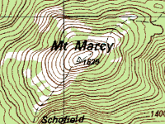
B. 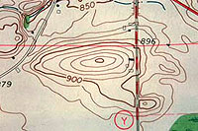 | E. 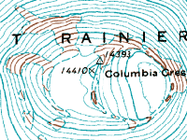
C. 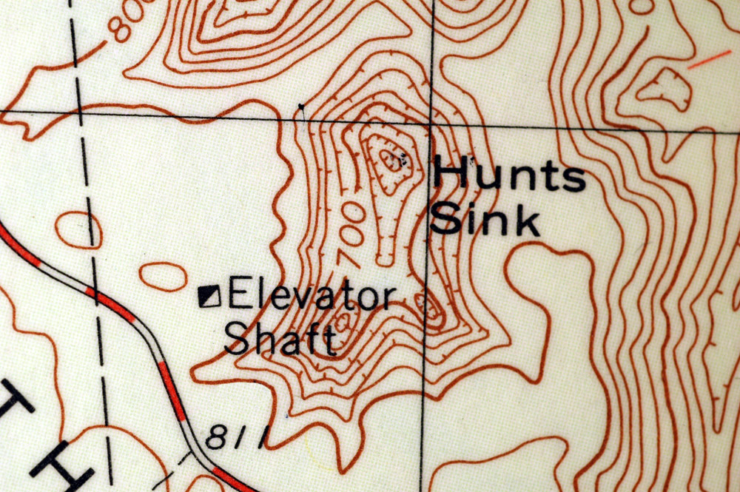 | F. 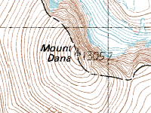

- The image below is at the intersection of an east-west and a north-south Trans Saharan trade route across the Sahara. The city-state was an intellectual and spiritual capital in the 15th and 16th centuries. After long years of decline, this city is still a tourist destination and is a UNESCO World Heritage Site. NASA image.
- Dakar, Senegal
- Tripoli, Libya
- Agadez, Niger
- Timbuktu, Mali
