You watched it during
the Olympics!
Now you can try CURLING!

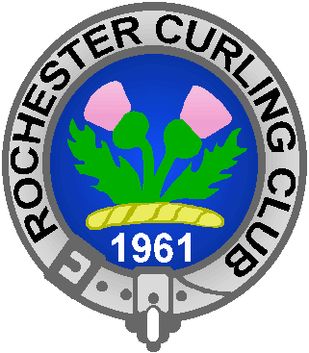
MCC Curling Party
Saturday, March 26th 4 – 6 p.m.
(Informal reception to follow)
at the Rochester Curling Club
71 Deep Rock Road (off Brooks Ave)

Sign up deadline is Wednesday, March 23rd
Call 292.2393 or
e-mail jhill3@monroecc.edu to register
$20 per adult (18 yrs and older)
$12 per child (11 – 17 yrs) [cash or check only]
Includes: Instruction, curling & cash bar

What should we wear?? The air is normally 38 degrees F on the curling ice, so you should dress warmly. Wicking fabric & removable layers: turtleneck, fleece or sweatshirt, flexible athletic pants, thin leather-palmed gloves or our curling mittens AND a hat. Jeans can restrict your movement and can be cold. There are locker rooms for changing. Please see the Rochester Curling Club website for more information.
PLEASE CARRY your “clean curling shoes” into the building as the parking lot tends to be snowy or muddy. This helps keep the ice as dirt free as possible to allow the curling stones to slide freely.
All participants are required to sign an Adult Participant Release form prior to going onto the ice. Also, for children less than 18 years old, a parent or legal guardian must also sign their Minor Participant Release form. Please bring these with you (extra forms will be available).

