Emergency Campus Sheltering

Save the Date!

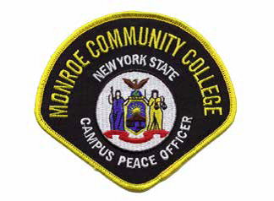

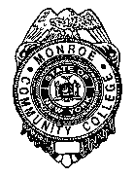
Brighton
Campus

Damon

Sponsored by the MCC Department of Public Safety

Wednesday, March 12, 2014
12:00 pm – 12:50 pm (College Hour)

The Monroe Community College Department of Public Safety will hold a Brown-Bag Session entitled EMERGENCY CAMPUS SHELTERING on Wednesday 03/12/14 from 12-12:50PM (College Hour) in the Forum (3-130).

The information shared will address why campus sheltering is needed during an emergency, the definitions/information detailing lockdown procedures and what systems are used to keep you informed during in the case of an emergency.

RSVP by March 11th to Inv. Rich Schill at
rschill001@monroecc.edu or 292-2926

