Ad Astra 7.0
Training Manual

Glossary
Introduction
Loading webpage and logging in
Home Tab
Calendars Tab (viewing events and classes)
Events Tab (requesting events)

Welcome to Ad Astra! This scheduling system allows the user to view all facilities for the Brighton, Damon and Applied Technology campuses. As a user, you will be able to
- View academic and non-academic events
- View available classrooms, lecture halls and meeting rooms
- Submit requests for the use of facilities (classrooms, lecture halls and meeting rooms)
Note: The Astra system may show rooms that are controlled /scheduled by departments. If those locations are requested, you will be alerted and would need to contact the controlling department to reserve the facility.

Loading Webpage and Logging In
Load Webpage
Open Internet Explorer and type in the webpage
Log in http://mcc-astra.monroecc.edu/AstraProd7/Portal/GuestPortal.aspx
Enter your MCC user name into the username text box
Enter your MCC password into the password text box
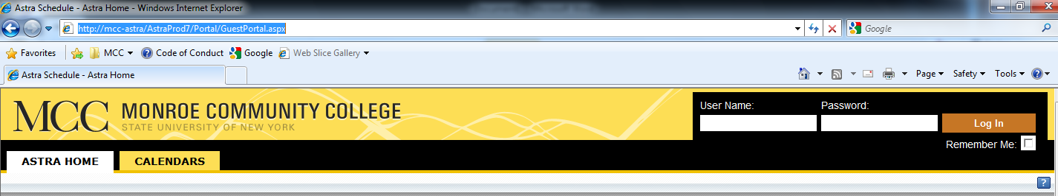

When you log in you will see 3 tabs: Astra Home, Calendars, and Events
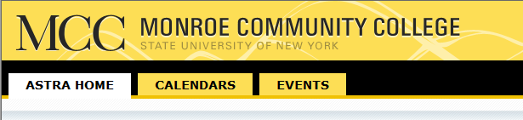
  - Astra Home
    - Is where you will find the most up to date information about Ad Astra Scheduling Software
  - Calendars
    - Is where you will view the calendar of events and classes for the Applied Technologies Center, Brighton Campus, and Damon City Center
  - Events
    - Is where you will request events
Note: You may have more tabs.

Home Tab
Astra Home Tab:

This page will be slightly different for each user but basically this will be the look of the page.
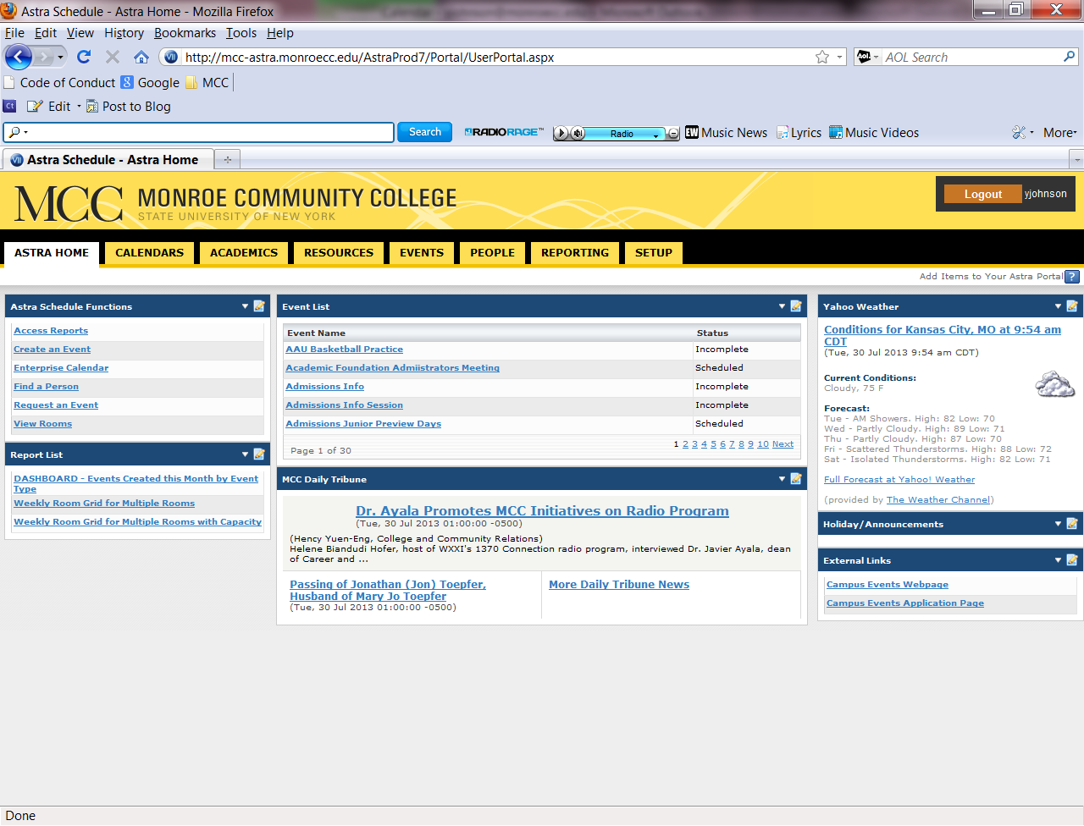

Calendar Tab
Calendars Tab:
This tab is where you will see what events and classes are taking place
Select “Scheduling Calendars”

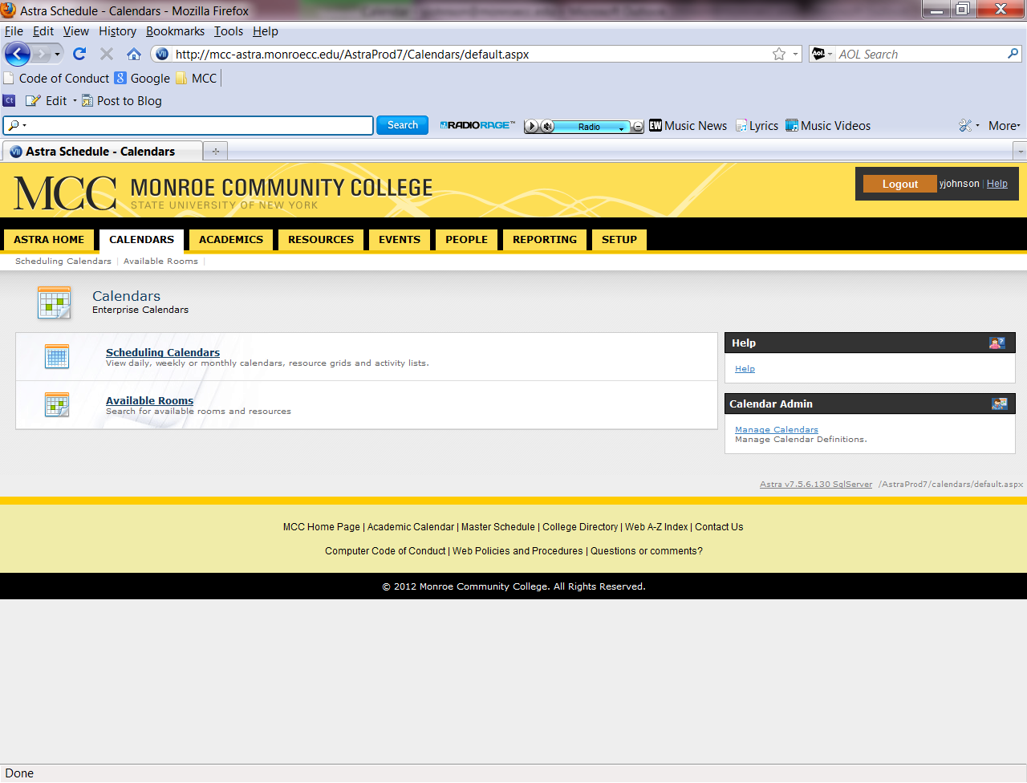
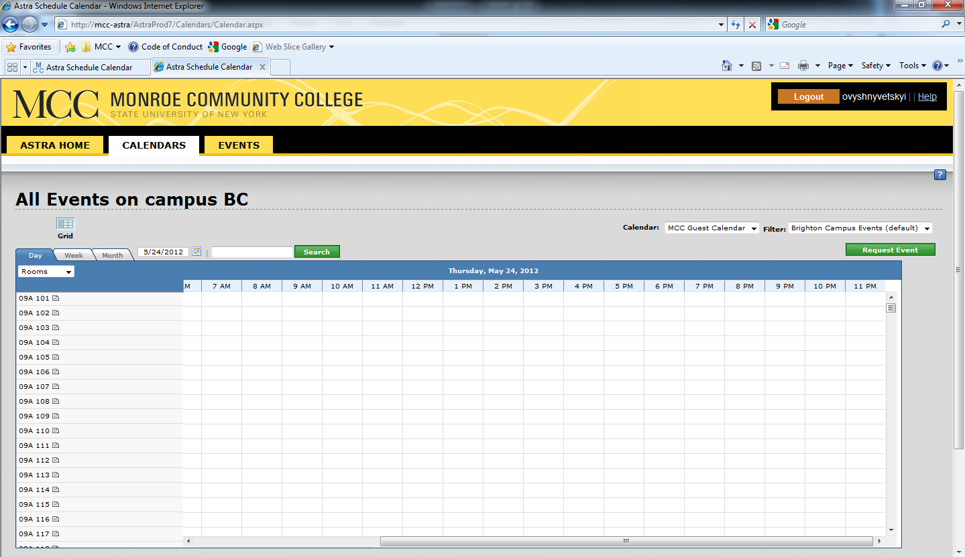

The default for the Grid View will be the “Day” view for the Brighton Campus.
Under the Day view you will see events in the grid:
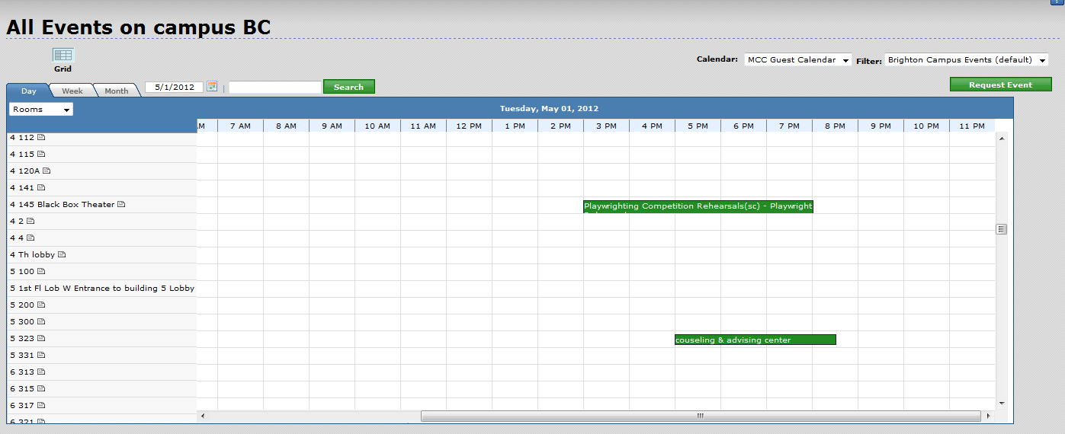
If you mouse over the event you will be given more details.
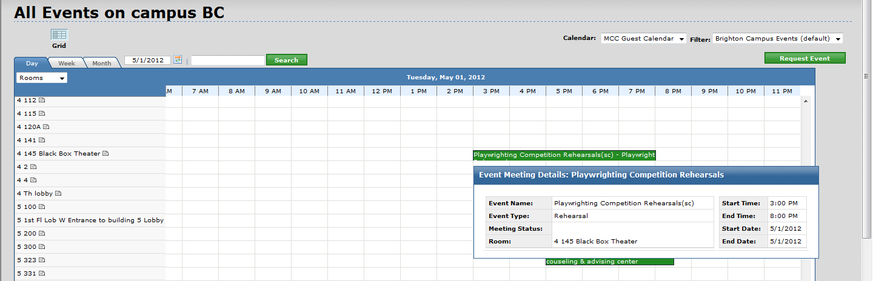

For “Week” view you see events within a week span.
You will need to click on a specific room on the left column (to do what?).
You will notice that when the room on the left column is red there are events in that space:
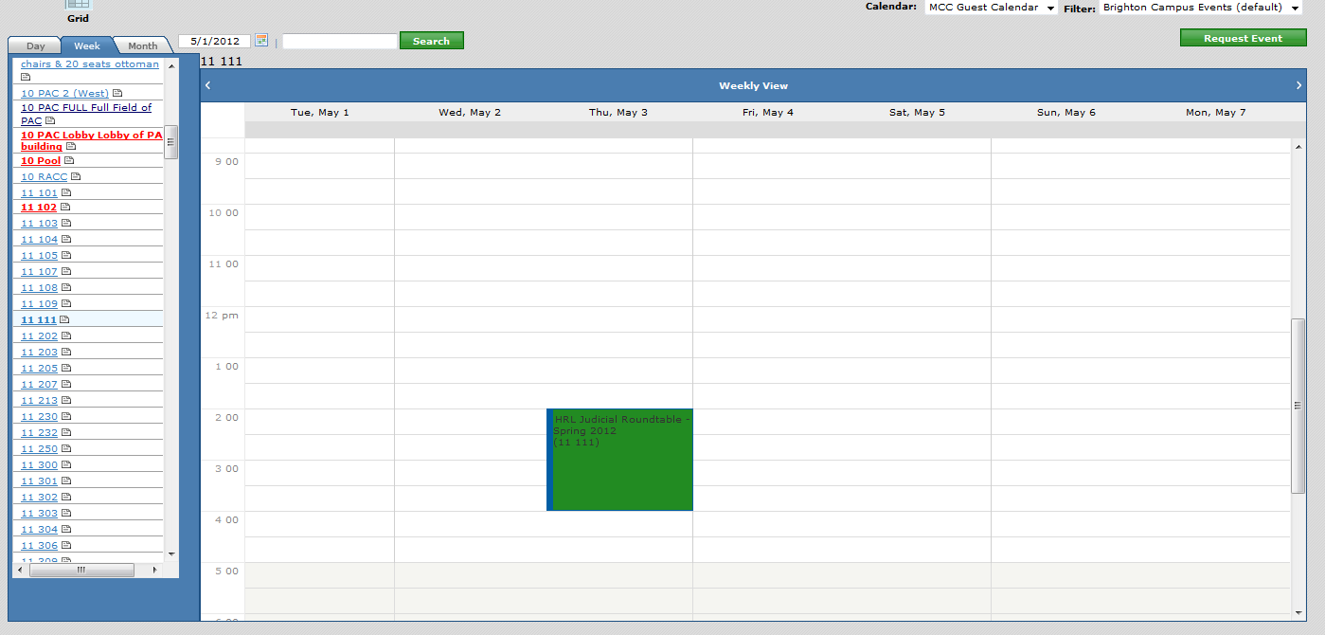

In the “Month” view you will see events within a month span.
You will need to click on a specific room on the left column (to do what?).
You will notice that when the room on the left column is red there are events in that space.
To amend the view
Click week
Click month

To search for an event

To view the ATC, Brighton or Damon calendars click the drop down menu on the top right. You have the options for each campus for events and each campus for events and classes.
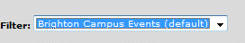

To amend the date

Event Tab
Events Tab:
To request an event, you will select the Events tab:
Click Event Request
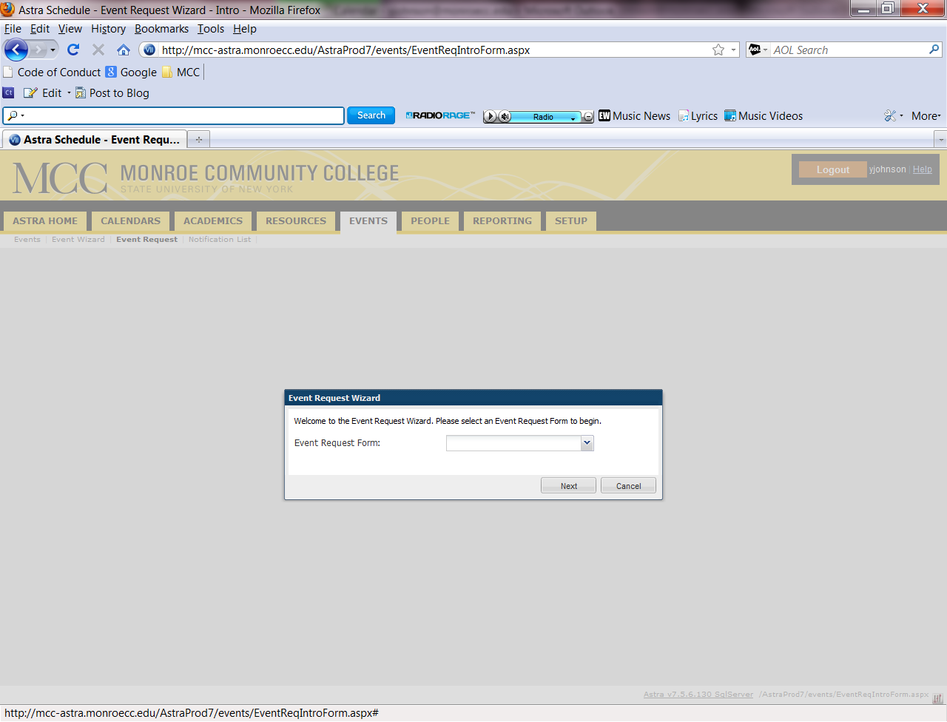
Click the drop down to define the request form
These will correlate with the campus that you are requesting facility in
Brighton, ATC, and Damon
Note: Disregard the Guest User Form. This request form should be used to reserve meeting rooms, classroom and lecture halls only. For Conference rooms (Monroe A, B, Empire, Forum, Brighton, Terrace, Campus Center Atrium, North Dining, Marketplace Bausch and Lobby lobby), theater, gym or Athletic areas please contact the Campus Events at 292-2010 or by email.
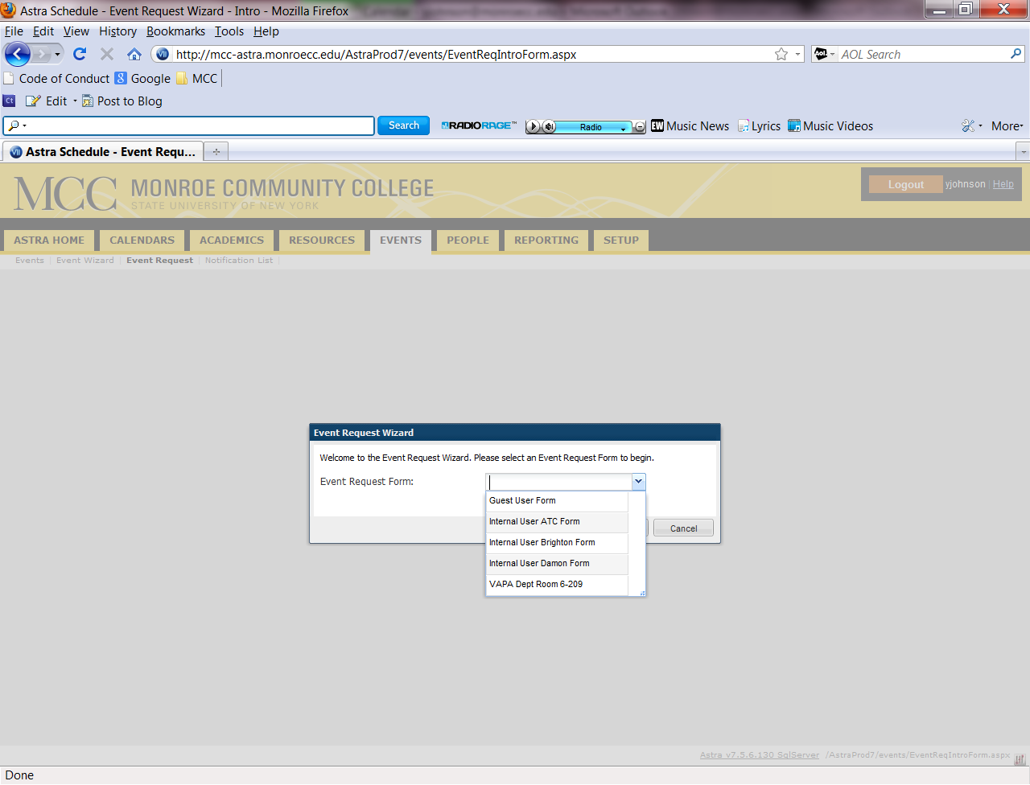
Select your desired form and Click next
Note: For the following input boxes, any that have an asterisk (*) the information is required
Enter your name and phone number. Your email address will automatically appear in the Email Address input box.

Enter your event details

(You need to define what “event description” should be)
Note: For any external attendees, you would need to provide an organization and account number for processing. You can place this information in the “Other Information” input box at the bottom of the form.
Enter your meeting name, type and description
You will also need to select your event date and time. Use the arrows to select the month and year that you are looking to reserve. Once you’ve chosen the information, click “Create”.
Please specify or describe the room that you would like to reserve. You can also describe your catering , AV, furniture, or other equipment needs.

Add any other information that you feel is relevant to your event or click “Visit Campus Events” to go directly to the Campus Events Webpage
Click Back, Save, or Cancel
Your ATC request will go to Courtney Sprague.
Your Damon request will go to Antonia Custodio
Your Brighton request will go to Que system where is will be handled by Yolanda Johnson, Courtney Sprague or Campus Events Assistant

To Log out:
Click log out in the top right
